**Developer Environment Setup Documentation**

**Introduction**

This document outlines the step-by-step process for setting up a robust and productive developer environment suitable for software engineering projects. The environment includes the installation and configuration of essential tools such as Windows 11, Visual Studio Code, Git, GitHub, Python, and MySQL. Additionally, this document provides troubleshooting steps and reflections on the challenges faced during the setup process.

**Installing Windows 11:**

I already have an operating Windows 11 installed in my computer. When I first installed it in 2023, I used the upgrade method from windows 10. I had the Windows 10 key which I used to activate the Windows 11. This method was suitable for me at that moment because the process dragged my old files, settings and programs from my previous windows system to the new one.

Here is an image of my current operating system.

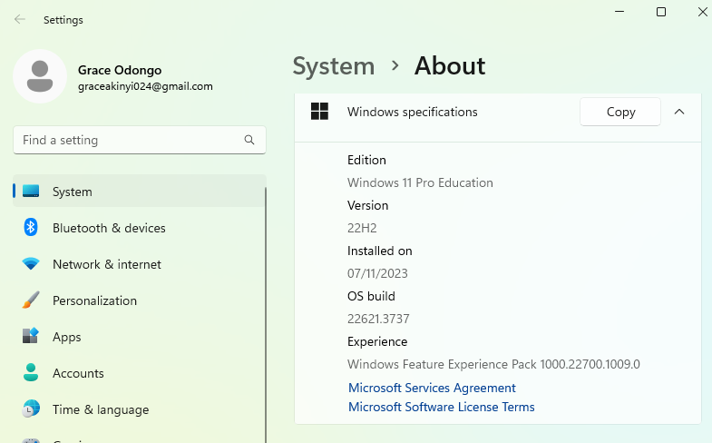

**Installing Visual Studio Code:**

I visited this link ([Download Visual Studio Code - Mac, Linux, Windows](https://code.visualstudio.com/Download)) where I downloaded visual studio code for Windows 11. I then run the installer. When the installation process ended, I launch the VS code.

Below is the image of my final output.

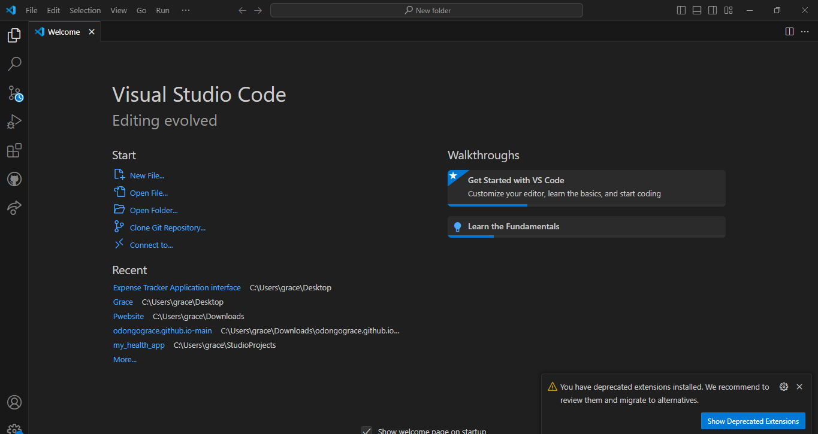

**Git and GitHub account:**

I have a functioning git page with a GitHub account which I created earlier in 2019. I downloaded the git from the Git official website and run the installer with its default settings. I then created a GitHub account by signing up for a new account. I then created a repository and cloned my repository. I also created and committed a README file.

Below is the image of my account.

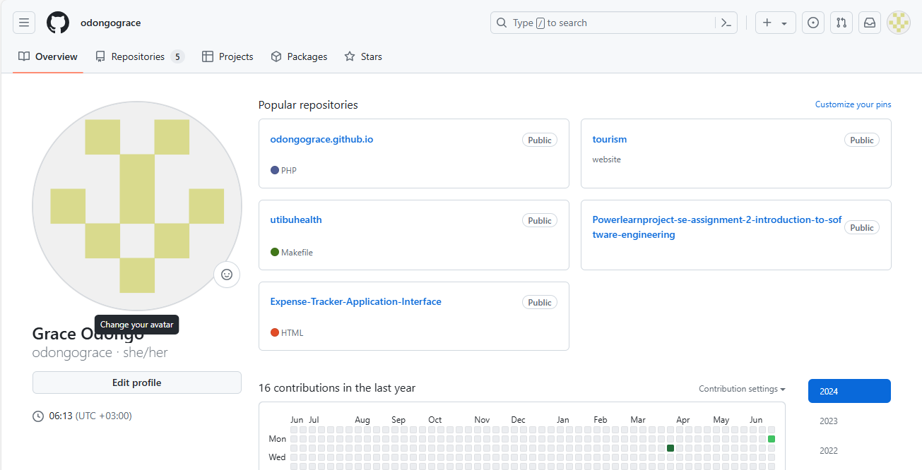

**Installing Python:**

I visited the following link ([Download Python | Python.org](https://www.python.org/downloads/)) and downloaded the latest version of python; which was Python 3.12.4.

I then clicked on the installer. Below is the output.

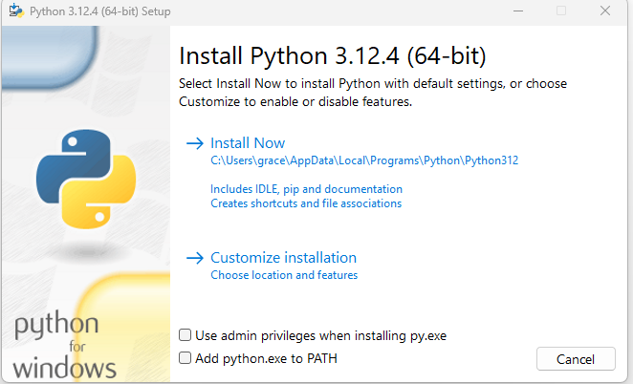

I checked the two checkboxes below to set up the Python path automatically, and selected the Install Now Option.

There was a pop-up message to allow the app to make changes on the device.

The installation Process.

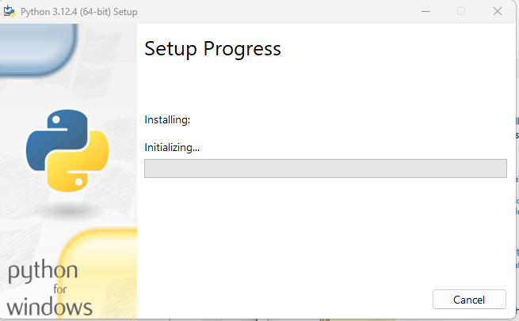

Once the installation process was done as shown below, I run python on the command prompt.

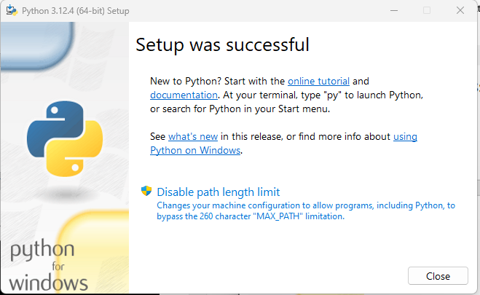

The installation was a success and the command prompt also revealed the version of python installed.

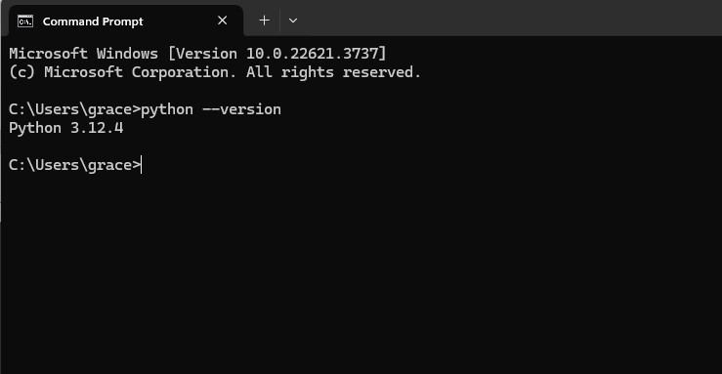

**MySQL:**

I already have an operating MySQL.

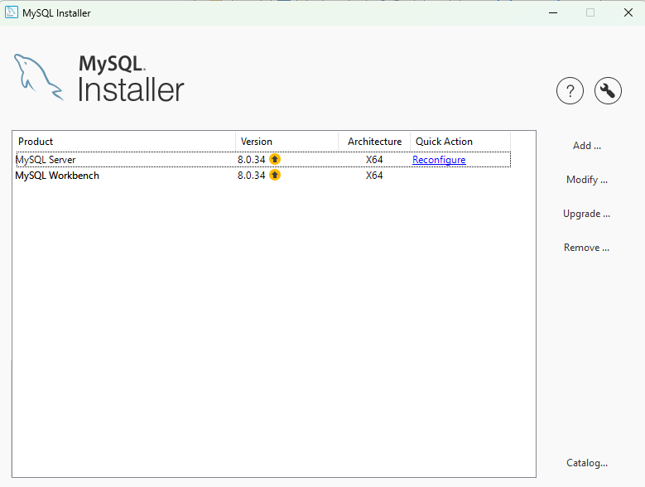

What I did was to upgrade the versions.

MySQL is now up to date and operational. I remember using a connection string to connect it to the database.

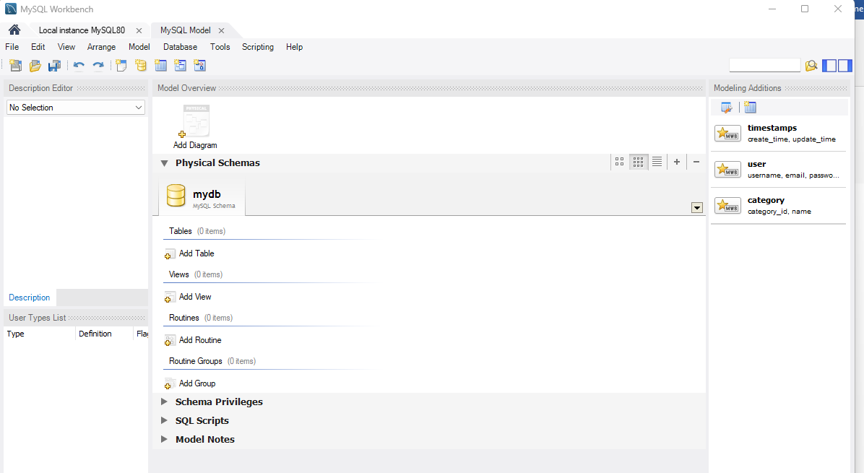

**Problems and Solutions:**

* MySQL Configuration: Configuring MySQL initially failed due to port conflicts. I changed the default port and ensured no other services were using the same port thus resolving the problem.

Overall, the setup process enhanced my understanding of configuring a development environment, highlighting the importance of meticulous attention to installation and configuration steps. This experience will undoubtedly aid in setting up efficient workspaces for future projects.